FRONT OF HOUSE: TIPS FOR DEALING WITH COVID-19 RESTRICTIONS
These are simply suggestions.
Organizations are encouraged to adapt this document as needed to fit their protocols.

Talking Points
In addition to clear signage detailing all the safety policies, front of house staff should inform all patrons of safety expectations at entry.
- At (insert name of org), we pledge to protect the health and safety of all who come through our doors, and work within our organization.

- Our policies related to health and safety are communicated via (insert ways information provided). There are no exemptions to these policies.

What to do if safety policies are not followed once a patron enters the venue.

Should a patron not comply to your organization’s policy, be sure front of house staff knows who he/she can immediately contact in order to address the situation.

- Name of employee, department -- It should be someone in attendance at that time in order for the employee to continue working the front of house.
- Be sure that dedicated staff person is readily available and knowledgeable about steps to be taken.

Confirming vaccine or test status.

- Negative COVID-19 Test Result (within the time frame indicated in your organization’s policy) – see samples of negative test results below
- COVID-19 Vaccination Card/Record – see samples below of vaccination card and acceptable apps.

Examples of Negative COVID-19 PCR Test Results

- Because of the dangers of forgery, there are very few examples of this documentation available on the internet
- ALL test results should contain the following information:
a. Patron name
b. Date of test (from here you can determine the required 72-hour window)
c. Location of test
d. The test will be noted as a PCR test
e. Test results
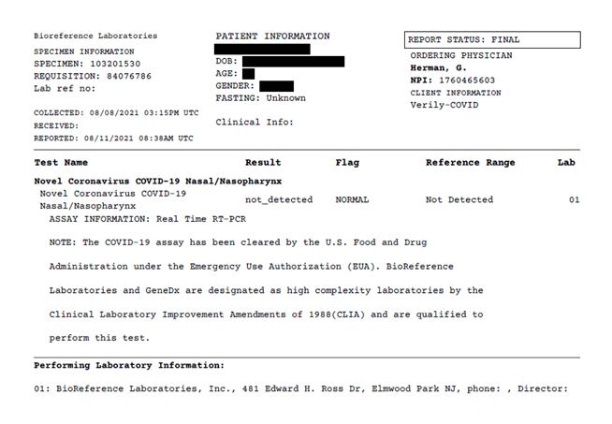

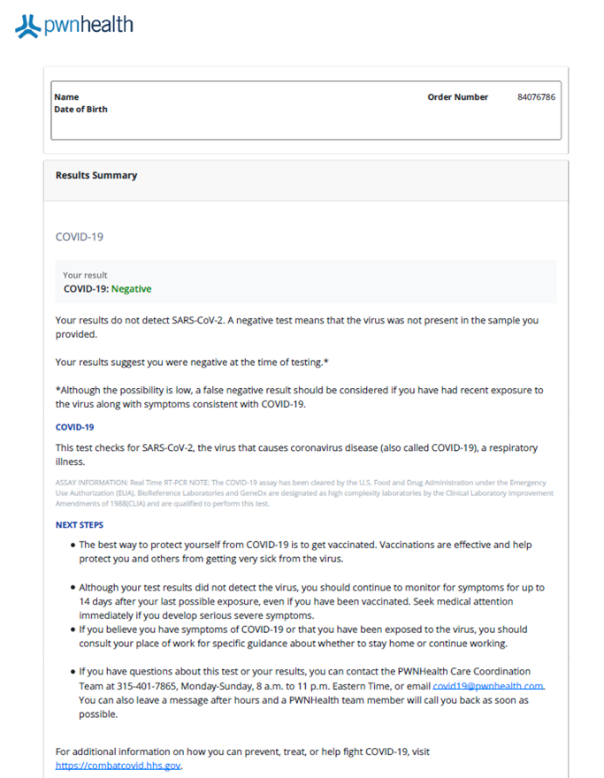

Examples of COVID-19 Vaccination Card/Record
      - CDC Vaccination Card (Physical card or photo of card is acceptable)
- If Pfizer/Moderna, there should be two shot dates listed
- Check to be sure two weeks have passed since the date of the second vaccine
- If Johnson & Johnson, there will be one shot date listed
- Check to be sure two weeks have passed since the date of the single vaccine
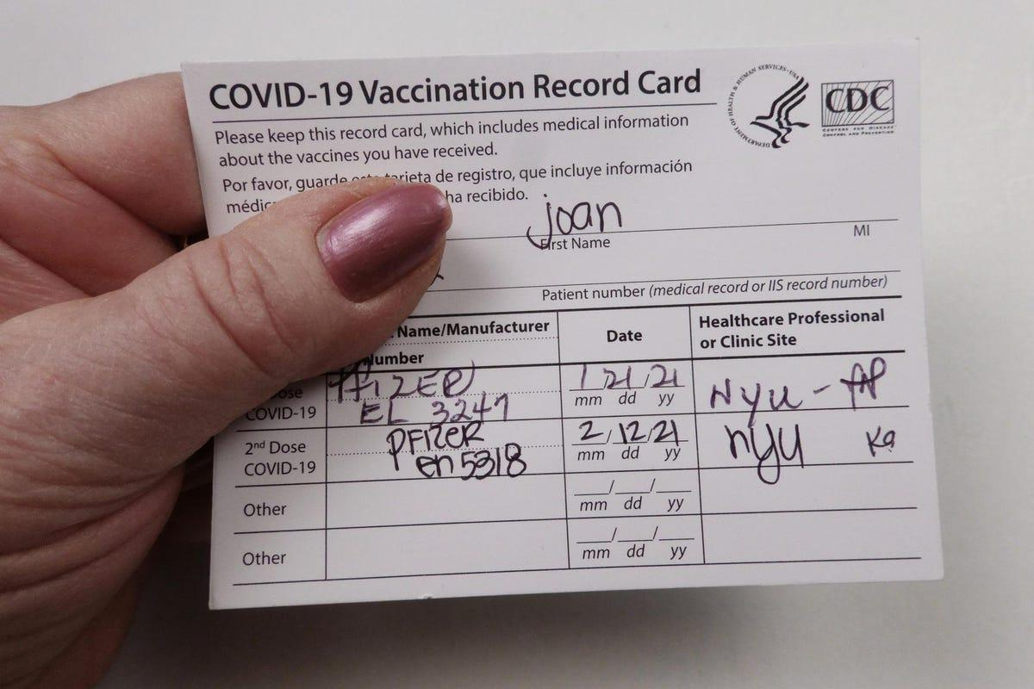

2. Docket App through New Jersey Immunization Information System
a. Screen 1 should notate the patron’s name and vaccine received
b. Once the patron taps that screen, details of the vaccine(s) will be provided – dates, type of vaccine and location

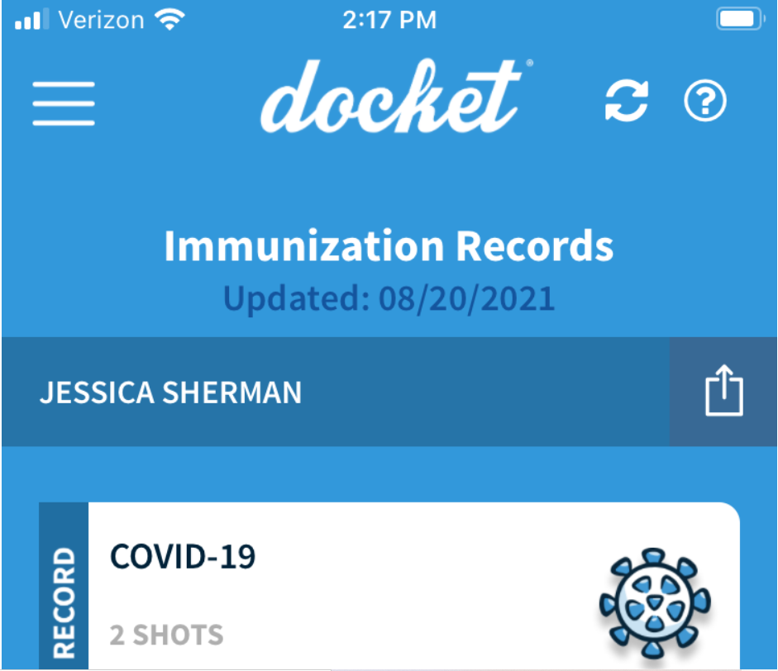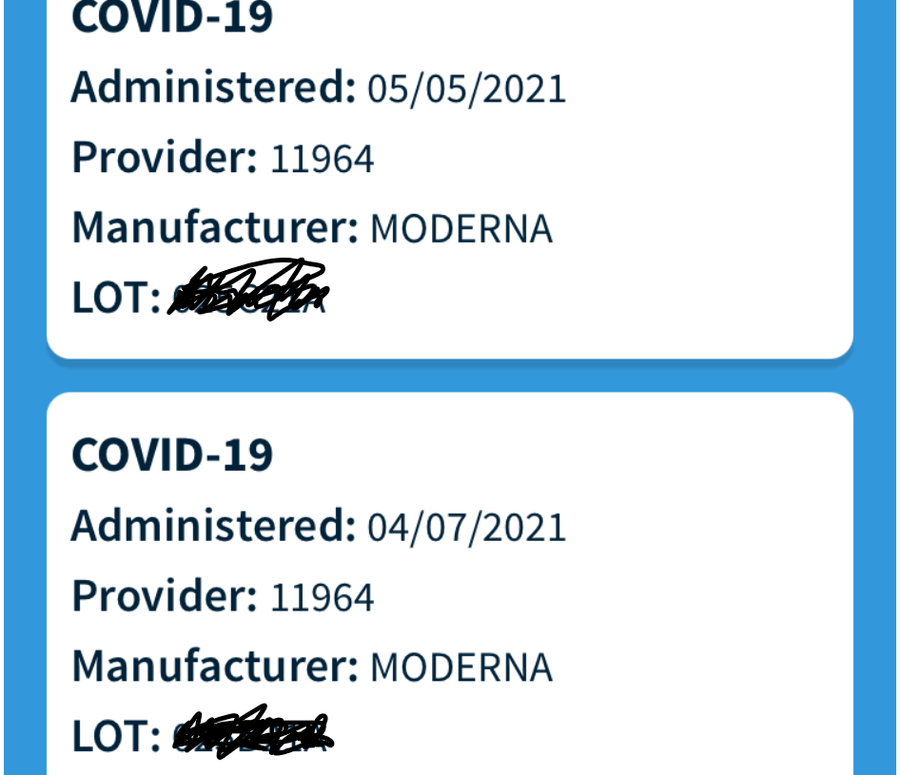

3. Excelsior Pass/Excelsior Pass Plus – New York’s APP/digital proof of COVID-19 vaccination or negative test results. View this 2 minute video to learn more.

Businesses in NY have a separate app called Excelsior App Scanner to scan the QR code that shows up on the app/printed documentation from Excelsior. TRT does not have this scanner, however, the information on the paperwork/app itself provides all the data needed.
